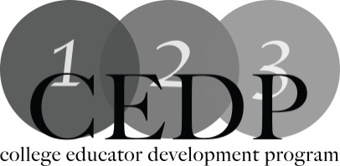

Academic dishonesty: who is cheating who?

Workshop Description:
In this workshop we will look at the issues facing college professors when it comes to academic dishonesty, present recent finding on academic dishonesty and discuss possible solutions.

Learning Outcomes:
1.Identify types of academic dishonesty that occur both inside and outside the classroom in various modes of delivery.
2.Identify methods used by experts in the field to understand what can be done to curb academic dishonesty,
3.Identify ways that professors may be inadvertently encouraging students to cheat.

Facilitators: Sue Prestedge, Mohawk College and Chris McCrory, Mohawk College

For more information: susan.prestedge@mohawkcollege.ca

Chris.mccrory@mohawkcollege.ca

Resources:
1.A useful site to use with students for the purposes of illustrating plagiarism:
http://www.plagiarism.org/
2.How to stimulate discussion about academic integrity in the classroom:
https://www.quinnipiac.edu/prebuilt/pdf/wac/database_fifty_ways_academic_integrity_0811.pdf
3.Definition of Plagiarism,what causes it and how to help students avoid it:
> http://honesty.uci.edu/AcademicHonestyTips.pdf

